The University of Lahore, CS&IT Department

# **Afzal khan 70070418**

# Assignment-1

Start-Date 12-03-2021 Section-A Total Marks 10

Due-Date 22-03-2021 Program: BSCS

**XML Code**:

<?xml version="1.0" encoding="utf-8"?>

<RelativeLayout xmlns:android="http://schemas.android.com/apk/res/android"

xmlns:app="http://schemas.android.com/apk/res-auto"

xmlns:tools="http://schemas.android.com/tools"

android:layout_width="match_parent"

android:layout_height="match_parent"

android:orientation="vertical"

tools:context=".MainActivity">

<FrameLayout

android:layout_width="wrap_content"

android:layout_height="match_parent"

android:visibility="gone"

android:id="@+id/sidebar_space">

</FrameLayout>

<!--app top bar -->

<LinearLayout

android:layout_width="match_parent"

android:layout_height="wrap_content"

android:background="@color/purple_500"

android:orientation="horizontal"

android:id="@+id/topbar"

android:padding="20dp"

android:weightSum="3">

<LinearLayout

android:layout_width="match_parent"

android:layout_height="match_parent"

android:layout_weight="1.2">

<TextView

android:layout_width="match_parent"

android:layout_height="match_parent"

android:drawableLeft="@drawable/ic_baseline_dehaze_24"

android:id="@+id/sidebar_opener"

android:textColor="@color/white" />

</LinearLayout>

<LinearLayout

android:layout_width="match_parent"

android:layout_height="match_parent"

android:layout_weight="0.8">

<TextView

android:layout_width="match_parent"

android:layout_height="match_parent"

android:text="Assignment"

android:textColor="@color/white" />

</LinearLayout>

<LinearLayout

android:layout_width="match_parent"

android:layout_height="match_parent"

android:layout_weight="1"

android:weightSum="2"

android:orientation="horizontal">

<TextView

android:layout_width="match_parent"

android:layout_height="match_parent"

android:layout_weight="1"

android:drawableRight="@drawable/ic_baseline_search_24"

android:textColor="@color/white" />

<TextView

android:id="@+id/opt"

android:layout_width="match_parent"

android:layout_height="match_parent"

android:drawableRight="@drawable/ic_baseline_more_vert_24"

android:layout_weight="1"

android:textColor="@color/white" />

</LinearLayout>

</LinearLayout>

<!-- 2nd -->

<LinearLayout

android:layout_width="match_parent"

android:layout_height="wrap_content"

android:layout_centerHorizontal="true"

android:layout_below="@+id/topbar"

android:padding="20dp"

android:layout_marginRight="130dp"

android:weightSum="3">

<LinearLayout

android:layout_width="match_parent"

android:layout_height="match_parent"

android:layout_weight="1"

android:orientation="vertical"

android:layout_marginLeft="15dp"

android:weightSum="2">

<TextView

android:layout_width="match_parent"

android:layout_height="match_parent"

android:drawableLeft="@drawable/ic_baseline_home_24"

android:layout_weight="1"

/>

<TextView

android:layout_width="match_parent"

android:layout_height="match_parent"

android:text="Home"

android:textColor="@color/blue"

android:layout_weight="1"

/>

</LinearLayout>

<LinearLayout

android:layout_width="match_parent"

android:layout_height="match_parent"

android:layout_weight="1"

android:layout_marginLeft="15dp"

android:orientation="vertical"

android:weightSum="2">

<TextView

android:layout_width="match_parent"

android:layout_height="match_parent"

android:drawableLeft="@drawable/ic_baseline_message_24"

android:layout_weight="1"

/>

<TextView

android:layout_width="match_parent"

android:layout_height="match_parent"

android:text="Message"

android:layout_weight="1"

/>

</LinearLayout>

<LinearLayout

android:layout_width="match_parent"

android:layout_height="match_parent"

android:layout_weight="1"

android:layout_marginLeft="15dp"

android:orientation="vertical"

android:weightSum="2">

<TextView

android:layout_width="match_parent"

android:layout_height="match_parent"

android:drawableLeft="@drawable/ic_baseline_info_24"

android:layout_weight="1"

/>

<TextView

android:layout_width="match_parent"

android:layout_height="match_parent"

android:text="Places"

android:layout_weight="1"

/>

</LinearLayout>

>

</LinearLayout>

<!--app bottom bar -->

<LinearLayout

android:layout_width="match_parent"

android:layout_height="wrap_content"

android:layout_alignParentBottom="true"

android:padding="20dp"

android:background="@color/purple_500"

android:weightSum="4">

<LinearLayout

android:layout_width="match_parent"

android:layout_height="match_parent"

android:layout_weight="1"

android:orientation="vertical"

android:layout_marginLeft="15dp"

android:weightSum="2">

<TextView

android:layout_width="match_parent"

android:layout_height="match_parent"

android:drawableLeft="@drawable/ic_baseline_favorite_24"

android:layout_weight="1"

/>

<TextView

android:layout_width="match_parent"

android:layout_height="match_parent"

android:text="Favorites"

android:layout_weight="1"

android:textColor="@color/blue" />

</LinearLayout>

<LinearLayout

android:layout_width="match_parent"

android:layout_height="match_parent"

android:layout_weight="1"

android:layout_marginLeft="15dp"

android:orientation="vertical"

android:weightSum="2">

<TextView

android:layout_width="match_parent"

android:layout_height="match_parent"

android:drawableLeft="@drawable/ic_baseline_music_note_24"

android:layout_weight="1"

android:textColor="@color/white" />

<TextView

android:layout_width="match_parent"

android:layout_height="match_parent"

android:text="Music"

android:layout_weight="1"

android:textColor="@color/white" />

</LinearLayout>

<LinearLayout

android:layout_width="match_parent"

android:layout_height="match_parent"

android:layout_weight="1"

android:layout_marginLeft="15dp"

android:orientation="vertical"

android:weightSum="2">

<TextView

android:layout_width="match_parent"

android:layout_height="match_parent"

android:drawableLeft="@drawable/ic_baseline_place_24"

android:layout_weight="1"

android:textColor="@color/white" />

<TextView

android:layout_width="match_parent"

android:layout_height="match_parent"

android:text="Places"

android:layout_weight="1"

android:textColor="@color/white" />

</LinearLayout>

<LinearLayout

android:layout_width="match_parent"

android:layout_height="match_parent"

android:layout_weight="1"

android:layout_marginLeft="15dp"

android:orientation="vertical"

android:weightSum="2">

<TextView

android:layout_width="match_parent"

android:layout_height="match_parent"

android:drawableLeft="@drawable/ic_baseline_menu_book_24"

android:layout_weight="1"

android:textColor="@color/white" />

<TextView

android:layout_width="match_parent"

android:layout_height="match_parent"

android:text="News"

android:layout_weight="1"

android:textColor="@color/white" />

</LinearLayout>

</LinearLayout>

<!-- options -->

<LinearLayout

android:layout_width="wrap_content"

android:layout_height="wrap_content"

android:padding="30dp"

android:visibility="gone"

android:id="@+id/options"

android:layout_weight="1"

android:orientation="vertical"

android:translationY="-20dp"

android:translationX="12dp"

android:background="@color/stone"

android:layout_below="@+id/topbar"

android:layout_alignParentRight="true"

android:layout_marginRight="@android:dimen/app_icon_size"

android:weightSum="3">

<TextView

android:layout_width="match_parent"

android:layout_height="match_parent"

android:padding="10dp"

android:textSize="15dp"

android:textColor="@color/white"

android:text="Update"

android:layout_weight="1"

/>

<TextView

android:layout_width="match_parent"

android:layout_height="match_parent"

android:textColor="@color/white"

android:padding="10dp"

android:textSize="15dp"

android:text="WikiGrid"

android:layout_weight="1" />

<TextView

android:layout_width="match_parent"

android:layout_height="match_parent"

android:padding="10dp"

android:textSize="15dp"

android:textColor="@color/white"

android:text="Sorting"

android:layout_weight="1" />

</LinearLayout>

</RelativeLayout>

**Java Code:**

package com.example.assigment2;

import androidx.appcompat.app.AppCompatActivity;

import androidx.fragment.app.Fragment;

import androidx.fragment.app.FragmentManager;

import androidx.fragment.app.FragmentTransaction;

import android.app.ActivityManager;

import android.content.Intent;

import android.os.Bundle;

import android.view.View;

import android.widget.Button;

import android.widget.FrameLayout;

import android.widget.LinearLayout;

import android.widget.TextView;

public class MainActivity extends AppCompatActivity implements

View.OnClickListener {

TextView btn,btn2;

LinearLayout ll;

FrameLayout sidebar;

Boolean check = false;

@Override

protected void onCreate(Bundle savedInstanceState) {

super.onCreate(savedInstanceState);

setContentView(R.layout.activity_main);

btn = findViewById(R.id.opt);

sidebar = findViewById(R.id.sidebar_space);

btn2 = findViewById(R.id.sidebar_opener);

ll = findViewById(R.id.options);

btn.setOnClickListener(this);

btn2.setOnClickListener(this);

}

@Override

protected void onStart() {

super.onStart();

FragmentManager fm = getSupportFragmentManager();

if (fm.getBackStackEntryCount() > 0) {

fm.popBackStack(null, FragmentManager.POP_BACK_STACK_INCLUSIVE);

}

}

@Override

public void onClick(View view) {

FragmentTransaction ft =

getSupportFragmentManager().beginTransaction();

Fragment frag;

Intent intent;

if(view.getId() == btn.getId()) {

check = !check;

ll.setVisibility(check == false ? view.VISIBLE : view.GONE);

}

if(view.getId() == btn2.getId()) {

sidebar.setVisibility(view.VISIBLE);

frag = new SidebarFragment();

ft.replace(R.id.sidebar_space, frag);

ft.addToBackStack(null);

ft.commit();

}

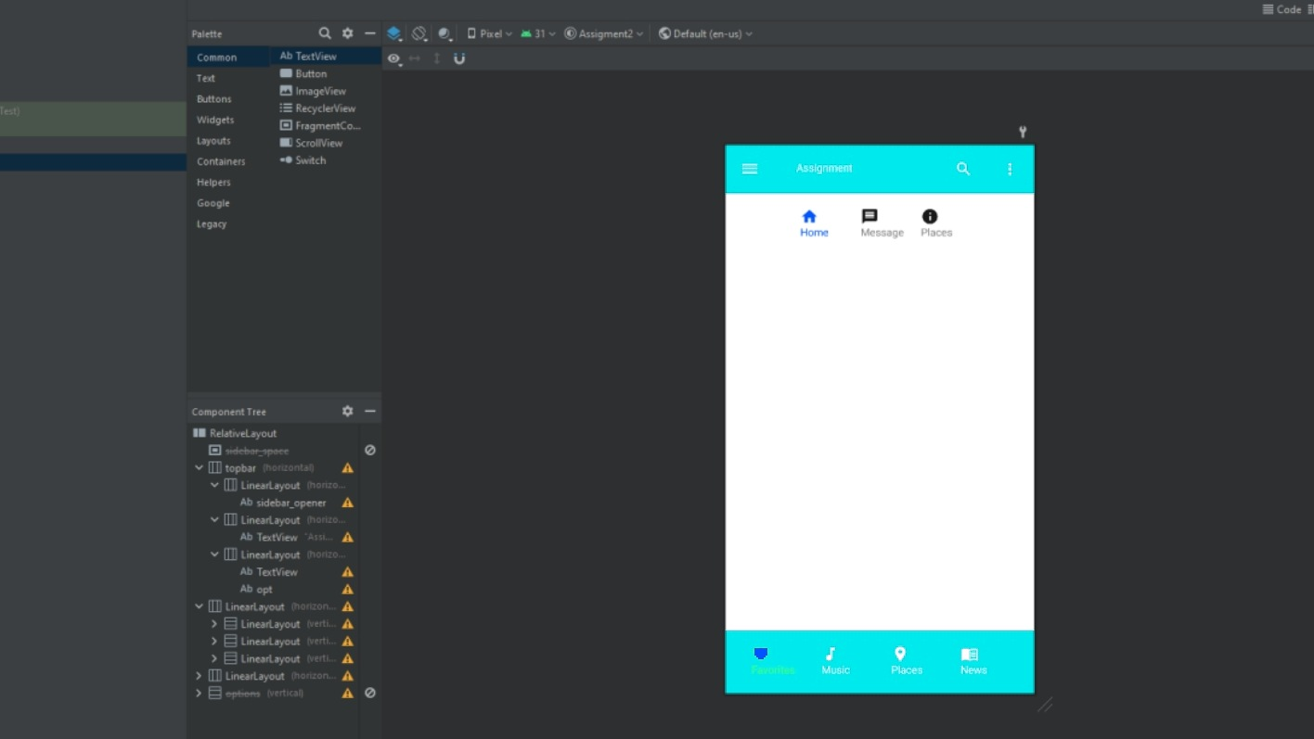

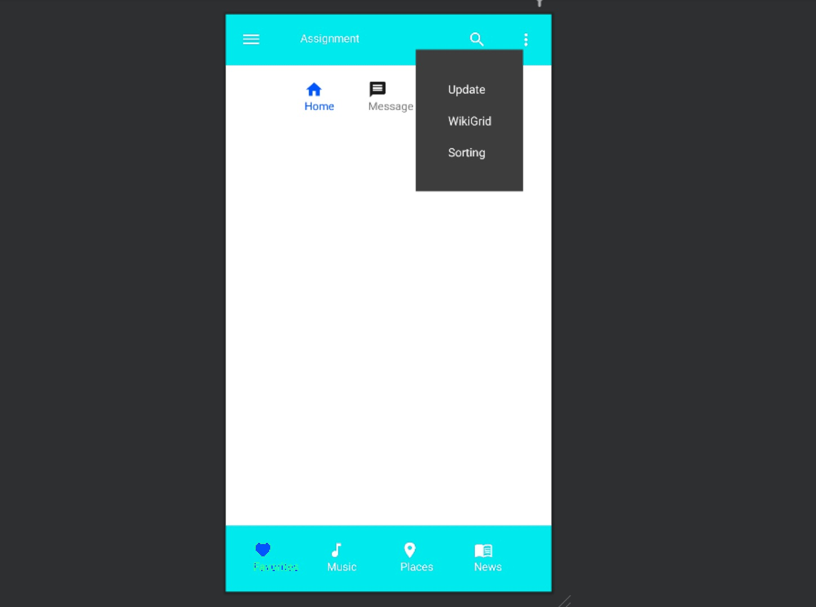

**Fragment Xml Code:**

<?xml version="1.0" encoding="utf-8"?>

<FrameLayout xmlns:android="http://schemas.android.com/apk/res/android"

xmlns:tools="http://schemas.android.com/tools"

android:layout_width="200dp"

android:layout_height="match_parent"

android:padding="20dp"

android:orientation="vertical"

android:maxWidth="@android:dimen/notification_large_icon_width"

android:background="@color/stone"

android:backgroundTint="#80FFFFFF"

android:backgroundTintMode="src_atop"

tools:context=".SidebarFragment">

<LinearLayout

android:layout_width="match_parent"

android:layout_height="match_parent"

android:layout_marginTop="55dp"

>

<LinearLayout

android:layout_width="match_parent"

android:layout_height="wrap_content"

android:orientation="vertical">

<ImageView android:id="@+id/image_view"

android:layout_width="match_parent"

android:layout_height="wrap_content"

android:adjustViewBounds="true"

android:maxWidth="52dp"

android:maxHeight="52dp"

android:scaleType="fitCenter"

android:layout_marginLeft="3dp"

android:src="@drawable/img_avatar"

/>

<TextView

android:layout_width="match_parent"

android:layout_height="wrap_content"

android:text="Name"

android:textSize="17dp"

android:textColor="@color/white"

android:textAlignment="center"/>

<TextView

android:layout_width="match_parent"

android:layout_height="wrap_content"

android:layout_marginTop="10dp"

android:textSize="17dp"

android:text="abc@gmail.com"

android:textColor="@color/white"

android:textAlignment="center"/>

</LinearLayout>

</LinearLayout>

<LinearLayout

android:layout_width="match_parent"

android:layout_height="wrap_content"

android:layout_marginTop="175dp"

android:orientation="vertical">

<Button

android:layout_width="match_parent"

android:text="My folder"

android:textSize="10dp"

android:drawableLeft="@drawable/ic_baseline_folder_24"

android:layout_height="match_parent"/>

<Button

android:layout_width="match_parent"

android:text="shared with me"

android:textSize="10dp"

android:drawableLeft="@drawable/ic_baseline_share_24"

android:layout_height="match_parent"/>

<Button

android:layout_width="match_parent"

android:text="Starred"

android:textSize="10dp"

android:drawableLeft="@drawable/ic_baseline_star_rate_24"

android:layout_height="match_parent"/>

<Button

android:layout_width="match_parent"

android:text="Recent"

android:textSize="10dp"

android:drawableLeft="@drawable/ic_baseline_access_time_24"

android:layout_height="match_parent"/>

<Button

android:layout_width="wrap_content"

android:text="close"

android:layout_marginTop="50dp"

android:id="@+id/closebtn"

android:layout_height="match_parent"/>

</LinearLayout>

</FrameLayout>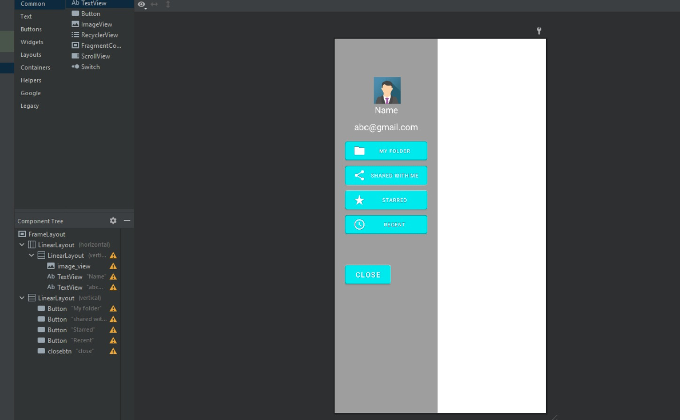

**Fragment Java Code:**

package com.example.assigment2;

import android.content.Intent;

import android.os.Bundle;

import androidx.fragment.app.Fragment;

import android.view.LayoutInflater;

import android.view.View;

import android.view.ViewGroup;

import android.widget.Button;

public class SidebarFragment extends Fragment implements View.OnClickListener

{

Button close_btn;

Intent intent;

@Override

public void onCreate(Bundle savedInstanceState) {

super.onCreate(savedInstanceState);

}

@Override

public View onCreateView(LayoutInflater inflater, ViewGroup container,

Bundle savedInstanceState) {

View view = inflater.inflate(R.layout.fragment_sidebar, container,

false);

close_btn = view.findViewById(R.id.closebtn);

close_btn.setOnClickListener(this);

return view;

}

@Override

public void onClick(View view) {

if(view.getId() == close_btn.getId()) {

//fl.setVisibility(view.GONE);

intent = new Intent(this.getActivity(),MainActivity.class);

intent.setFlags(Intent.FLAG_ACTIVITY_NO_HISTORY);

startActivity(intent);

}

}

}